**Laboratory work No. 3. Calculation of the**

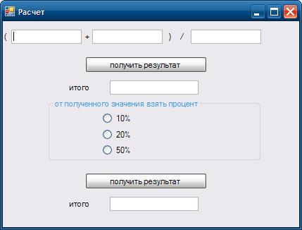

rest Label

1. Set the following components on the form, as in the figure.
2. This form uses a simple calculation (x + y) / I; and an opportunity is made to get a different percentage of the calculated.

create the Click event on the first button to get the result

private void button1_Click (object sender, EventArgs e)

{

double i = Convert.ToDouble (textBox1.Text);

double b = Convert.ToDouble (textBox2.Text);

double c = Convert.ToDouble (textBox3.Text);

double result = (i + b) / c;

textBox4.Text = Convert.ToString (result);

// or

//textBox4.Text = Convert.ToString ((Convert.ToDouble (textBox1.Text) + Convert.ToDouble (textBox2.Text)) / Convert.ToDouble (textBox3.Text));

}

on the second button the Click event

private void button2_Click (object sender, EventArgs e)

{// check which radiobutton was selected

if (radioButton1.Checked == true)

textBox5.Text = Convert.ToString (Convert.ToDouble (textBox4.Text) * 10/100);

if (radioButton2.Checked == true)

textBox5.Text = Convert.ToString (Convert.ToDouble (textBox4.Text) * 20/100);

if (radioButton3.Checked == true)

textBox5.Text = Convert.ToString (Convert.ToDouble (textBox4.Text) * 50/100);

}